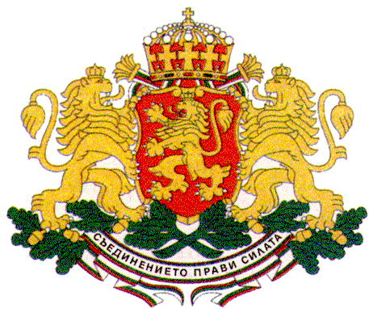 | PERMANENT MISSION OF THE REPUBLIC OF  BULGARIA  TO THE UNITED NATIONS

11 East 84th Street, New York, NY 10028, Tel: (212) 737 4790, Fax: (212) 472 9865, e-mail: bulgaria@un.int

ECOSOC High-level Political Forum on Sustainable Development, UNHQs, New York, 10 - 19 July 2017

Bringing Awareness and Action on the SDGs to the Classroom:
A Presentation of Students’ Experience with the World’s Largest Lesson Exploring SDGs 2 (Zero Hunger) and 3 (Good Health)

New York, 14 July 2017, 1.15 pm – 2.30 pm, UNICEF House

H.E. Ms. Ofeliya Kaneva, President of the State Agency for Child Protection, Council of Ministers of Bulgaria

Your Excellency Mr. Peter Thomson, President of the General Assembly,
Mr. Anthony Lake, Executive Director of UNICEF,
Excellencies,
Distinguished Guests,

It is my honour to address you today on behalf of the Government of Bulgaria.
Bulgaria is strongly committed to promoting children’s rights and ensuring children’s participation in all processes affecting their lives. All child policies in Bulgaria follow a rights-based approach taking into consideration the best interest of the child principle and the views and opinion of children themselves. Bulgaria firmly believes that no decision or initiative should be taken or realized without the meaningful participation of children and the Bulgarian Government makes every effort to ensure children’s effective involvement in all processes that affect childhood and define the future.
UNICEF is a valuable partner and plays a crucial role in all major national initiatives related to child rights.

Bulgaria has been actively advocating, including as co-chair of the Group of Friends of Children and the SDGs, for children’s participation at global level as well and for recognizing children as agents of change and not mere recipients of policies designed by others. A tremendous step forward in this regard was made with the adoption of the 2030 Agenda for Sustainable Development and we are committed to making child agency a reality.
I would like to give a concrete example of how Bulgaria ensures child participation and child agency in practice. In accordance with the principles of the Convention on the Rights of the Child a Children’s Council was established by the Government of Bulgaria in 2003 which resembles the Council of Ministers in its mission and objectives with the only difference that it is entirely composed of children. 33 children from all parts of Bulgaria are elected through a transparent and inclusive process to serve a two-year term as members of the Council.
The work of the Children’s Council mirrors the agenda of the National Child Protection Council which is Bulgaria’s main child rights coordinating body, and has as its main objective to ensure that children’s positions on issues related to their rights are fully taken into consideration by the decision-makers. No deliberation of the Council of Ministers of Bulgaria related to children’s rights goes without consulting children and no legislative act on issues affecting children is adopted by the Government without taking into account children’s proposals.
A most recent example is the Pre-school and School Education Act in force since 2016 which was drafted in close consultation with children and made a crucial step forward also in the efforts of the Bulgarian Government to bring the Sustainable Development Goals closer to children. With this new legislation knowledge on sustainable development was included as one of the 9 key competencies that children should acquire in school and the topic of sustainable development has been integrated in the curriculum throughout the whole course of education. Children are taught in a child-friendly way the main principles of sustainable development through a participatory learning process that motivates and empowers them to take action for sustainable development in their everyday activities thus promoting change in their communities and beyond.
With the adoption of the 2030 Agenda the international community renewed its commitment to child participation and the success of the Agenda would largely depend on how we manage to engage children as the real agents of positive change for sustainable development.
Bulgaria continues to advocate for child rights and child participation in all intergovernmental processes with the firm conviction that children should be at the heart of all global action.
Thank you!

